FLORIDA D.A.D. INC.

This pamphlet explains why there is a need for Florida D.A.D. Inc.. It also addresses who Florida D.A.D. Inc. is, as an organization, and what we are doing to transform the current laws and Family Court system to benefit our children. Please read this brochure carefully as some of this information may enlighten you on the ills of our system and/or personally help you.

Why there is a need for DADS !

COURT RULINGS
Every workday, in every region of the state of Florida, children are abused by and become victims of the family court process. Judges, in their rulings, fail to consider the mental, emotional and physical detriment to a child when they reduce/remove children from Father’s and Grandparents lives. Fathers are ordered to become a faceless income source with no verification that the child is the beneficiary. Frequently, The amount of money fathers have to pay to be involved with their children creates a dichotomy, in the sense that it costs more than a father can pay to be involved with their children. The only options they have are go to jail or pay what little they have and have no money to live on much less care for their children.

What happens when fathers are kept away¹
Children are more likely to be:
- An unwed Pregnancy 3 times more likely
- Poor 51%
- Teen Drug Abuse Over 50%
- School Dropout Over 50%
- Teen in Detention 78%

¹ Statistics published in the Florida Commission on Responsible Fatherhood Governor's Symposium Report 2000.

Thus, the government creates the much-maligned DeadBeat Dad, Welfare Dad, or the Disappearing Dad.

Florida D.A.D. Inc. continues to focus on legislative changes that mandate;
- The presumption of equal “parenting time”
- Realistic child support guidelines
- Justify child support is spent on the child(ren)
- Improved accountability for judges who violate the laws of the state.

THE ADVERSARIAL SYSTEM
The Family Court is adversarial by its design and is built around divorce, distribution of assets and custody. There are two sides, husband and wife. One is systematically facing the other as a foe. Each end up fighting for their “fair and equitable “ share of the marital assets and a relationship that was mildly irreconcilable evolves unfortunately into what is, a fight, battle or a war. One, which has an inevitable end: lose/lose. Why? Is it because the money one family lived on before the proceedings is now paying for two households, or is it that it is now paying for two attorneys, mediators, court reporters and a myriad of other fees and professionals, or is it both? Some of these same people, with little to no background, make their recommendations to the court about where they think your children should spend their time and because of this many children quickly become victims.
Of course, fathers will have to pay for each of these people regardless of the recommendations they make.
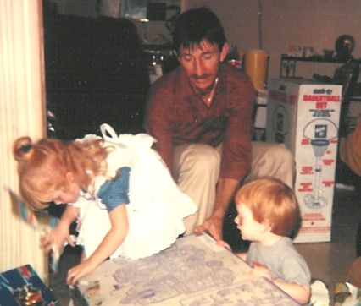
Financially there are those who can’t afford an attorney, and are forced to undertake this overwhelming system as a Pro Se litigant insuring little to no success.
It is evident that all phases of "family" court are neither comfortable with, nor willing to respect the idea that children need their fathers as equitably involved parents.

Florida D.A.D. Inc.:
- Provides insight, guidance and information to individuals in order to assist them in maintaining a healthy father and child relationship during and after divorce.
- Continues to research and work to replace the ineffectual and destructive adversarial Family Court system with an efficient, effective and equitable alternative that accomplishes the same purpose with less emotional and financial trauma to the family members.
- Is building a dynamic list of references of tradesmen and professionals, known to us across the state.

EMOTIONAL SUPPORT
Divorce and the breakup of any relationship is the hardest emotional crisis you will most likely face, second only to death of a close family member. The difference between the two is that in divorce there is no recovery from the grieving because you have lost the living. There is no support system to provide the help you or your children need so you and your children are left to grope in the dark to find your own method for coping.
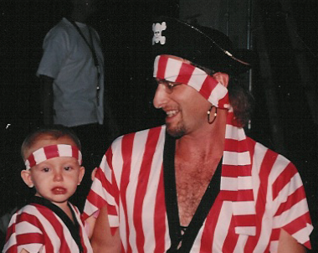
The System itself will act out their bias towards children and rule in such a way that fathers and grandparents are pushed further and further away from their children. Whether it is money or time the results are the same, children are alienated from their fathers. Children without fathers become wards of the State are less successful in life, more apt to be arrested, use drugs and have children as teenagers. They are penalized by the system and very few seem to care. No matter how much love you have there is nothing left for you to do but live with this result. It is now known that the biggest increase in suicides is among adult males directly linked to the forced loss of his children. In spite of all of this, you must maintain the proper composure or jeopardize what little chance your children have in maintaining a relationship with you.

Florida D.A.D. Inc. is committed to:
- Emotionally supporting your needs in this crisis for the benefit of your children, grandchildren and you
- Helping you deal with the tough questions that your children may ask or the emotions that they may display
- Guiding you to the correct resources that you may need while in this crisis

How you can help!

STAY THE COURSE!!
Patience and perseverance must prevail. Rome wasn’t built in a day and our children’s plight will only change if we “use the system”, maintain our determination and work towards equality. Our Children need us. Your children need you.

GET INVOLVED!!
We must get active, join together and create a voice that demands to be heard. If not with Florida D.A.D. Inc. then find a group that suits your needs. Contribute time and/or money for DAD sponsored projects. Experts of all trades and professions are desperately needed and everything costs. One hundred per cent of your donation to Florida D.A.D. Inc. is spent on helping children of divorce, especially to have their Dad in their lives.

Do your Part!

Corporations- Sponsor our Projects Join as Associate Members

Politicians- Ask questions and support child/parent friendly legislation

Media- Make the public aware of the inequities and injustices that removes children from their fathers

Everyone- Call YOUR LEGISLATIVE REPRESENTATIVES and tell them the truth about the system

and

DO IT NOW!

(954) 493-9763

http://www.dadsofflorida.org
info@dadsofflorida.org

P.O. Box 550231
Fort Lauderdale, Florida
33355-0231

The photographs located throughout this brochure are members of Florida D.A.D. Inc. and their children

Florida D.A.D. Inc.

DADS of FLORIDA

DADS

Committed to Improving the

Lives of children of divorce

